Change Your Yahoo Password Easily by Firefox Password Recovery

I forgot my yahoo password. And I can’t do the "Help" things because I put a fake secret question & birthday, & email when I registered the account. Please somebody can help me!!!?
I was wondering how to change my yahoo password, because I have been unable to change password. "My account" link is not working for me. Is there any other way that through which I can change my password?
…
I have been asked by too many times like those described as above. Indeed, we do pay very little attention to the password and its security question when we register the yahoo account. Perhaps one possible reason is that we rely on too much Firefox browser, because firefox is able to remember very password as well as username of the websites and emails we visit.

If you remember your yahoo password, then to change yahoo password is very easy. Here we do not discuss about it. But we would be more excitedly to talk about changing yahoo passwords when we lose them and their answers for secret questions.
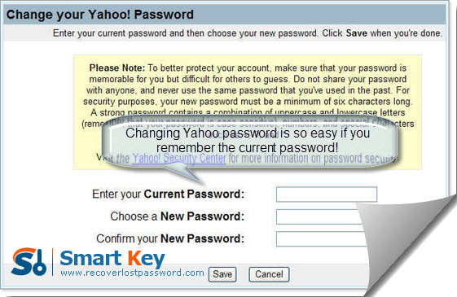
Like what I have said in paragraph 2, the reason that we always cannot remember our yahoo passwords is we save them on Firefox, then every time we log into yahoo mails from Firefox, we needn’t fill the login box. It is a development of Firefox, but also a recession of our memory for passwords. Next I intend to uncover the secret of changing yahoo password from Firefox but in a condition that Firefox has cleared your yahoo password information. Sounds amazing hah? Then let’s see it!

Now the yahoo password changer I am ready to introduce to you is Firefox Password Recovery 5.0. It is a very powerful utility to change your yahoo password and multilingual yahoo password recovery and change are efficiently supported by it. Next are the step-by-step tutorial guides to change yahoo password by Firefox Password Recovery 5.0.

Step1. Free download Firefox Password Recovery 5.0 in its website: 到时候再加，and then install it instantly.

Step2. Press “Start Recovery”. Less than seconds, the window will list a lot of websites and accounts as well as passwords.

Step3. Click “Remove From File”. (Optional) This step comes when your Firefox web browser is crashed. At this time, you can change your yahoo password by implementing “Remove From File”, because your password information is not lost permanently though the Firefox cannot remember it anymore. Usually, that information can be recovered or found from the Firefox profile directory. (PS. A typical path is :C:\Documents and Settings\＜username＞\Application Data\Mozilla\Firefox.

Step3. Click “OK” button, then your yahoo password together with its website URL and Username will be displayed.
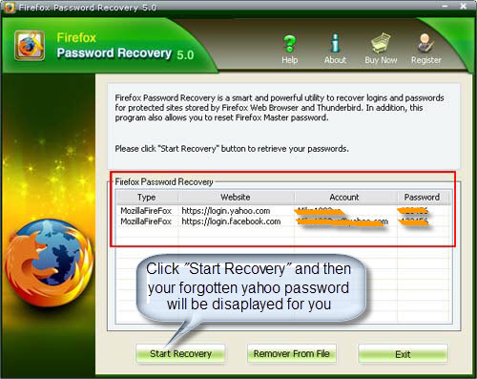
Until now you have already successfully changed your forgot yahoo password. One more suggestion, after you see you yahoo password displayed in front of you, then change it to straight away. But the new password should be easy for you to remember but not being too simple, at least 8 letters with numbers are highly recommended.

Article Source:
http://www.recoverlostpassword.com/article/change-yahoo-password.html

